**Audentes Parallel Line Analysis AT132 Infectivity Development Report Addendum**

**Prepared By:**

**BioAssay** SCIENCES

12653 Angels Gate

Highland, UT 84003 USA

**Prepared For:**

Astellas Gene Therapies

225 Gateway Blvd., South

San Francisco, CA 94080

|  |
| --- |
| **Daniel Harding**  Principal Consultant, BioAssay Sciences  [daniel.harding@bioassaysciences.com](mailto:daniel.harding@bioassaysciences.com)  +1 925-360-0494 |
| **Richard Walus**  Director Quality Systems, BioAssay Sciences  [richard.walus@bioassaysciences.com](mailto:richard.walus@bioassaysciences.com)  +1 801-372-1564 |

**Table of Contents**

1. Abstract…………………………………………………………………………………………………………...……...……3

2. Parallelism Acceptance Criterion Modification….…………………………………………..…….....………3

3. Linearity Acceptance Criterion Modification………………………………..………..…………..…….……..4

4. Infectious Particle Ratio Addition…………………………………………………………………………………………..7

1. **Abstract**

The following report provides the details of additions completed upon the parallel line analysis (PLA) JMP Script used to evaluate the AT132 Infectivity and A2016 Infectivity Assays for Astellas Gene Therapies (AGT). The report is divided into three sections: One section to explain the updated method for evaluating parallelism. Another section to explain the updates to the method for evaluating linearity. The final section explains the infectious particle ratio addition to the script. This addendum updates the script described in ‘Audentes Infectivity AT132 Assay Development Report 12November2020 v1.0’.

1. **Parallelism Acceptance Criterion Modification**

Previously parallelism was evaluated using the p-value of the interaction (Group* Log 10 MOI (Vg/cell)). If the p-value was greater than 0.05, then the assay was assumed to parallel. However, this was not the appropriate test for the most recent runs of the assay due to model overfitting with the included interaction. For that reason, the slope ratio was evaluated and found to be appropriate for the evaluation of parallelism. This methodology of evaluating parallelism is in accordance with agency guidance.

US Pharmacopeia (USP) (1032) Design and Development of Biological Assays

states the following:

*“For the parallel-line case, this [*the measure of nonsimilarity (nonparallelism)*] could be the difference or ratio of the slopes.*

The samples are subsequently evaluated for parallelism prior to fitting the constrained model using an equivalence test based on the slope ratio. If the slope ratio is within the upper and lower bound, then the model used is considered parallel. Currently the lower equivalence bound is 0.5 and the upper equivalence bound is 1.5.

Y Response: Log 10 Vg/mL

X Factor for parallelism using slope ratio: Log 10 MOI (Vg/cell)

Model: linear model grouped by Group column (test article and reference standard)

Test: The slope ratio is calculated by taking the slope from the sample model divided by the slope of the reference standard model. The slope ratio is compared with the equivalence bounds.

Having the slope ratio within the equivalence bounds indicates there is no significant difference in the slopes (i.e. they are parallel). Therefore, the model can be constrained to have different intercepts and common slopes. The model passes the parallelism criterion and is used to determine relative potency. If the slope ratio is outside of the equivalence bounds, the assay fails parallelism and is invalid.

Figure 1 is a parallelism test example with a resulting slope ratio of 0.89.



Figure 1 Parallelism Evaluation

1. **Linearity Acceptance Criterion Modification**

A normal part of a bioassay using a parallel line analysis method is the assessment of linearity (how straight the lines are). It can be measured three ways: 1) checking to see if the quadratic term of concentration is statistically significant (*p*-value ≤ 0.05). This is a direct method for assessing linearity. 2) Fit the full model, including the interactions and evaluate the Lack-of-Fit. This is an indirect method of assessing linearity. 3) Evaluate the linearity ratio. This is a direct measure of linearity and is a practical test similar to other tests of equivalence such as slope ratios.

Previously, the JMP Script used to evaluate the AT132 Infectivity Assay and the A2016 Infectivity Assay evaluated linearity based on probability tests (*p*‑value ≥ 0.05), as part of assay and sample validity determination. However, using probability based tests can be overly sensitive to small deviations in curvature. In addition, probability tests are not practically significant, demonstrate high repeatability at each concentration (overfitting) and generate false positives for nonlinear line detection. To address this issue, a “Linearity Ratio” method of linearity analysis was defined with the criterion of ≤ 20%. This methodology of evaluating linearity is similar to evaluating parallelism.

## Calculation of the Linearity Ratio

The Linearity Ratio method of analysis uses a measure of curvature relative to the linear line rather than a measure of probability by comparing the effect size attributed to the quadratic term (curve) to the effect size attributed to the linear term in the full model. In practical terms the question answered by the linearity ratio is what percent of the line is curving?

The fit model platform in SAS/JMP calculates the scaled estimate. A scaled estimate for the linear term is ½ the change in the signal over the range (distance from center). To determine the full change over the range linear effect of concentration (MOI), it must be multiplied by 2. The quadratic term is curvature; therefore, half of the change over the range of a curve is the full change over the range. Practically, as long as 80% of the signal is a linear change in the dose response the assay can be considered sufficiently linear to determine relative potency, or conversely as long as the linearity ratio is ≤ 20% the assay is considered to be sufficiently linear.

The Linearity Ratio formula is:

$$Linearity Ratio=|\frac{\left(Scaled Estimate Log 10 MOI \left(Vg/mL\right) Quadratic \right)}{\left(Scaled Estimate Log 10 MOI \left(Vg/mL\right) *2\right)}| * 100$$

The following example demonstrates the Linearity Ratio methodology:

Y Response: Log 10 Vg/mL

X factors and full model for linearity: Group, Log 10 MOI (Vg/cell), Group* Log 10 MOI (Vg/cell), Log 10 MOI (Vg/cell)*Log 10 MOI (Vg/cell).

The full effect scaled estimates (effect size) from the table below are used to calculate the slope ratio (Figure1). Log MOI (Vg/cell) is the linear term half effect and is multiplied by two for the full effect. The Log MOI (Vg/cell)* Log MOI (Vg/cell) is the quadratic term and is multiplied by one for the full effect.



Figure 2 Scaled Estimates

Using the circled values shown in Figure 2, the linearity ratio is 1.915%. The interpretation is that line curvature is only 1.915% of the linear line. With a criterion of ≤ 20%, this indicates the bioassay run is sufficiently linear to calculate potency and relative potency.

Using this method will result in a higher validity rate as well as the assay avoiding overpower due to sample size. In addition, a direct measure of line curvature will be used.

Following the format of the previous version of the script, the acceptance criteria and system suitability are evaluated and tabulated. Figure 3 below gives an example of the table with updated rows for the parallelism test and linearity test.

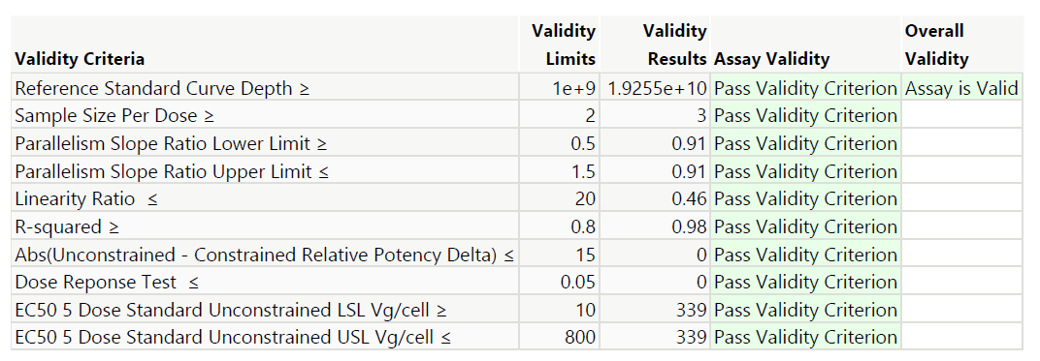

Figure 3 Updated Systems Suitability and Validity Report Section

1. **Infectious Particle Ratio Addition**

Through communication with the FDA, it was determined that the ratio of virus particle to infectious virus titer (aka the infectious particle ratio) should be added to the script that generates a report showing the results for each determination of each assay run. The infectious particle ratio is a direct measure of infectious units at a specific MOI.

The same constrained model used to calculate relative potency is used to calculate the infectious particle ratio. To calculate the infectious particle ratio, the formula in Figure 1.0 is used.

$$\frac{250}{Constrained EC50 at 9.9 Log 10 Vg per mL }$$

Figure 1.0 Infectious Particle Ratio Formula

In Figure 1.0 above, the numerator is the nominal total number of particles dosed on the plate. In this case, the total number of particles dosed on the plate is 250. The denominator is based on the historical average signal from the samples at the middle of the curve. The 9.9 Log 10 Vg/mL fixed position is used because using a fixed position will result in a characterization of the shift of the signal on any curve. Not using a fixed position would result in excessive variation in the infectious particle ratios. Ideally the ratio should be close to 1. Values above 1 denote error in the method.

The system suitability and limits section of the Excel configuration file used by the JMP script was updated to include limits for the slope ratio, linearity ratio, and infectious particle ratio (Figure 2.0).



Figure 2.0 System Suitability and Limits Section with Updated Criteria and Limits

Limits for the infectious particles ratio are preliminary and may be adjusted. The infectious particle ratio is not a validity criteria for a determination of an assay run, but a table containing the resulting limit and the limits from the configuration file are now part of the pdf report generated by the JMP script. Figure 3.0 provides an example of the infectious particle ratio table.

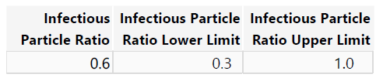

Figure 3.0 Infectious Particle Ratio Table